**Elasticsearch Installation + Querying Guide**

By: Noah Dunn and Scott Harris

1. Log into GCP
2. Select Elasticsearch from Google Click to Deploy in the search bar

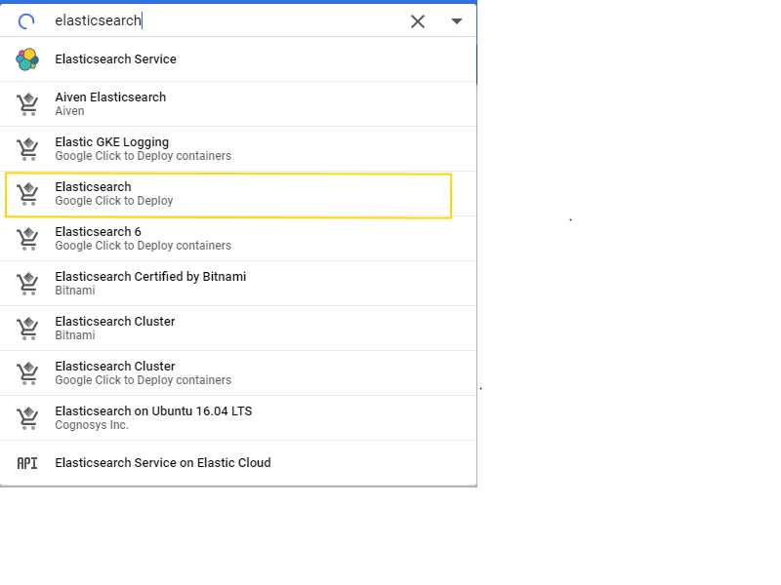

1. Hit Launch

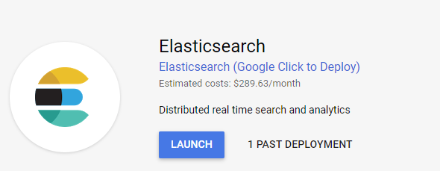

1. Configure the instance as follows, changing the deployment name

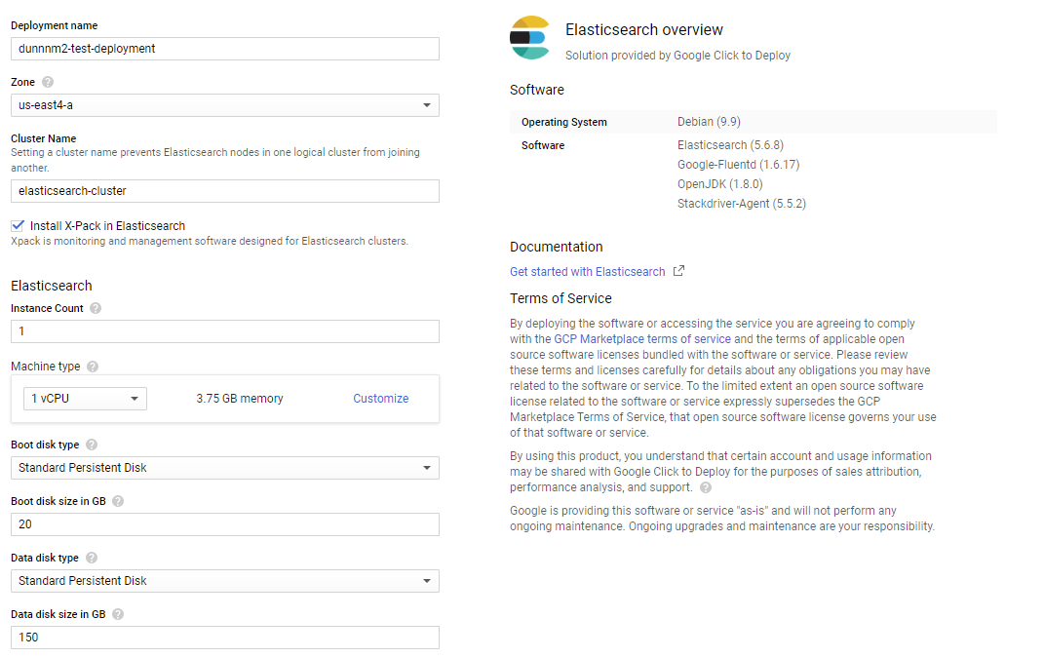

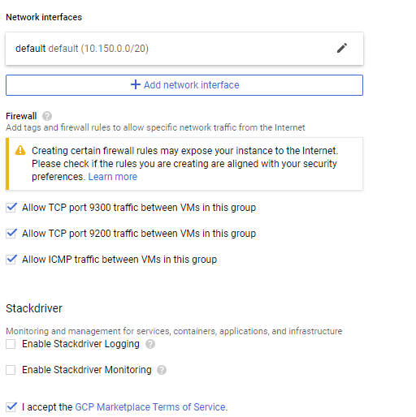

1. Hit Deploy  
   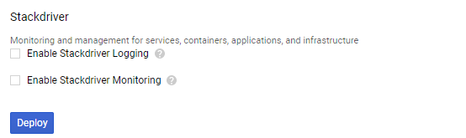
2. Allow Deployment to Process

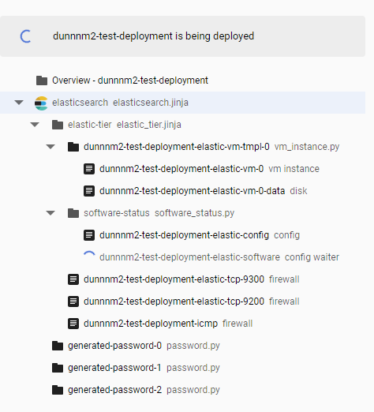

1. Deployment finishes

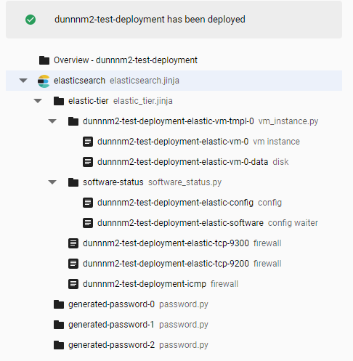

1. Make note of the user and password listed to the right of the deployment finish. If you forget this later, check the Deployment Manager in GCP.

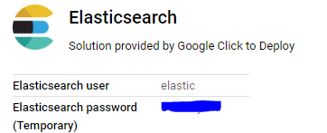

1. Navigate to the Compute Engine section of your GCP account

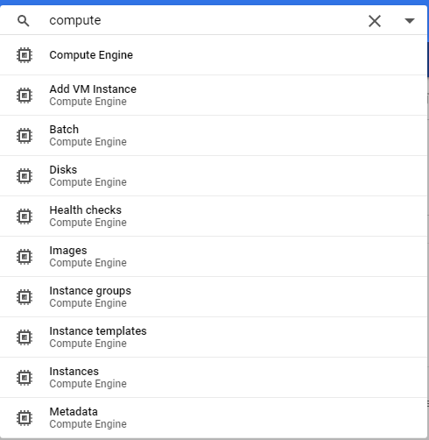

1. Make note of the ExternalIP here

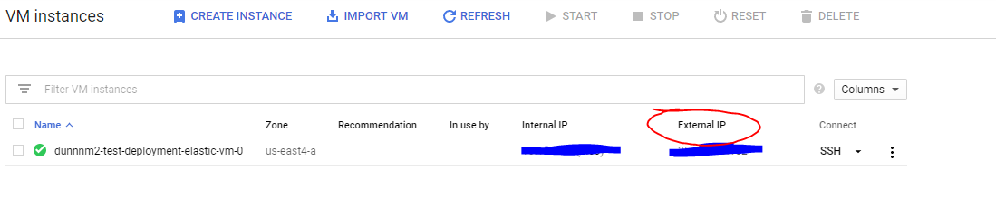

1. Select Firewall Settings options  
   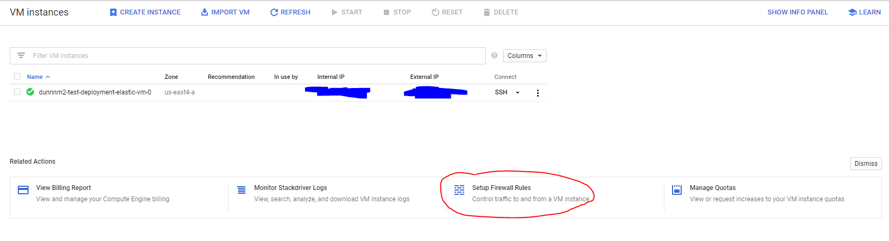
2. Select Create Firewall Rule

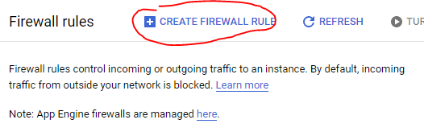

1. Configure a firewall rule to enable HTTP + HTTPS

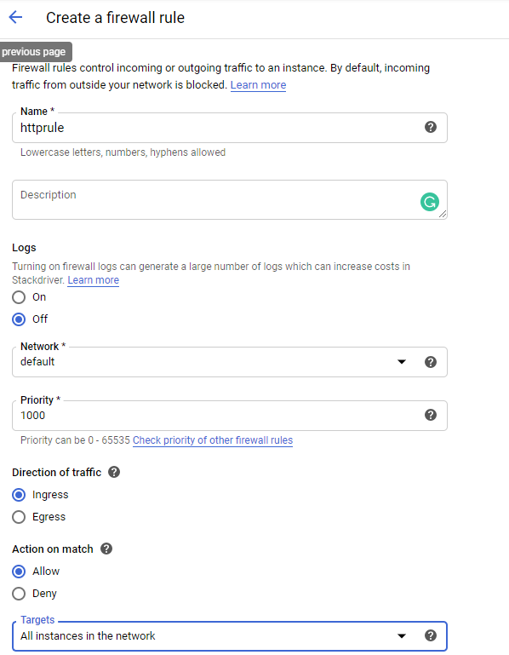

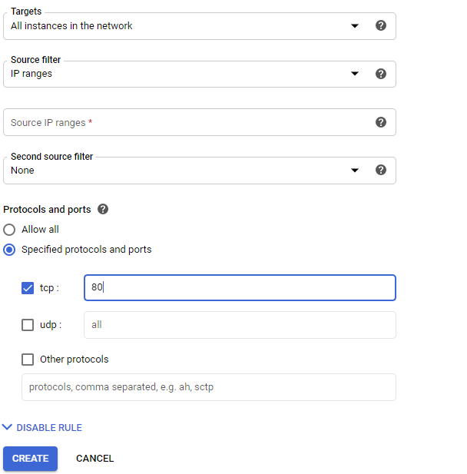

1. Install Postman
   1. Go to [www.postman.com](http://www.postman.com) and click “Download the App”  
      
   2. Select your OS and download/install Postman  
      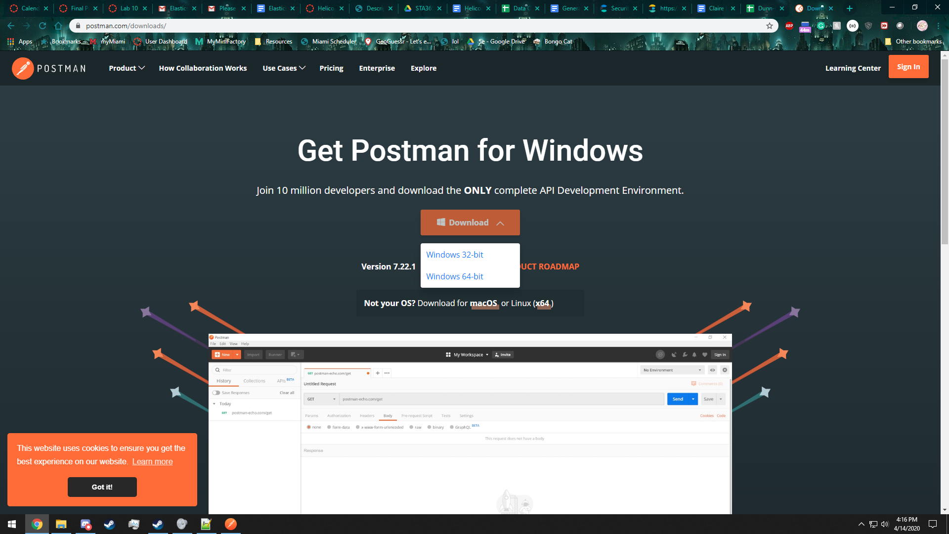
2. Using Postman
   1. Create a collection to store your requests using the “New” dropdown in the upper lefthand corner  
      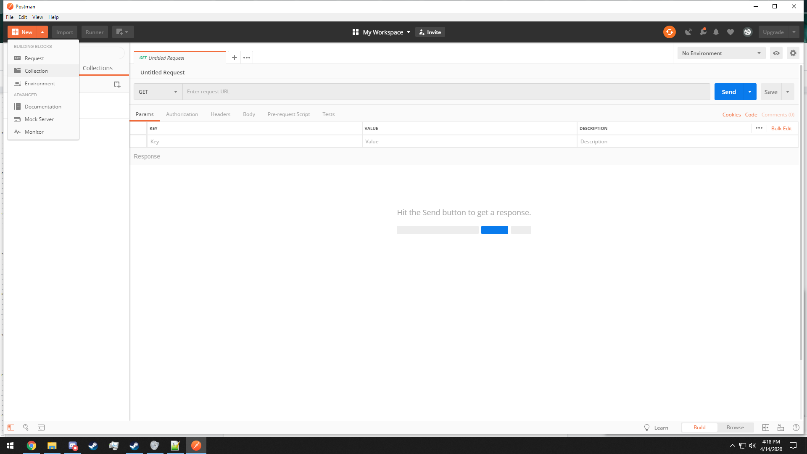
   2. Assign a name to the collection and click Create  
      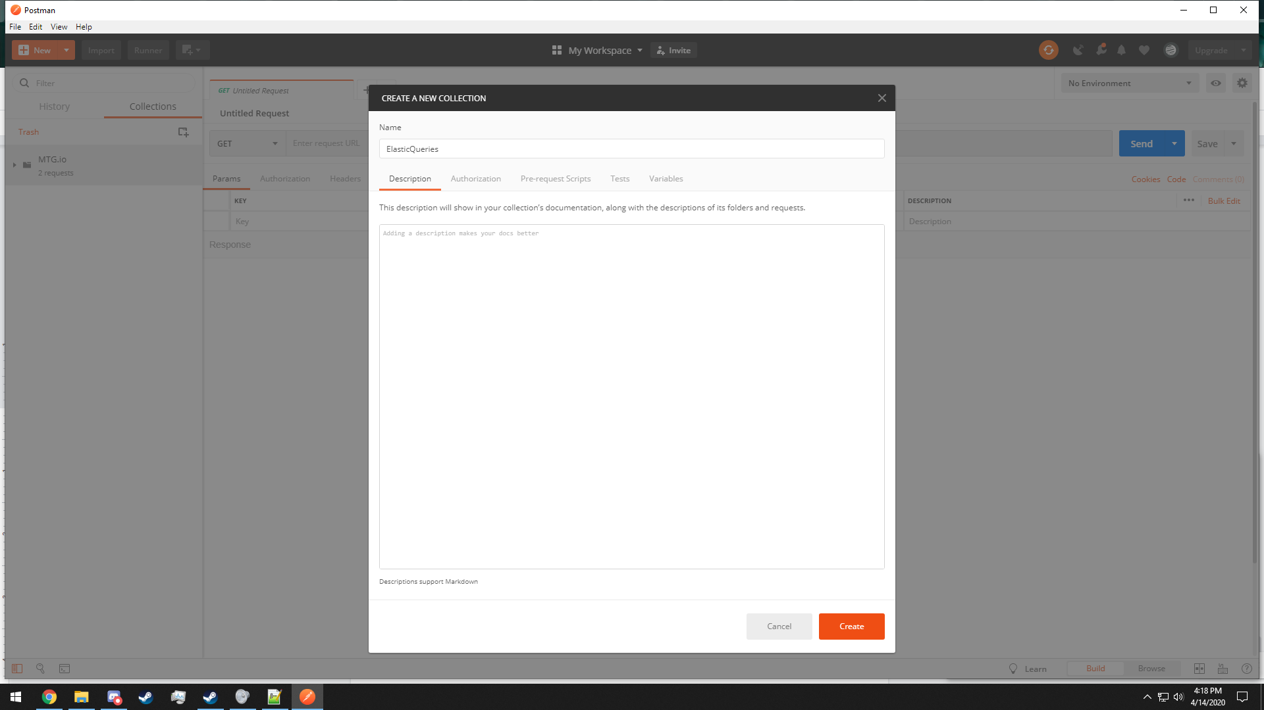
   3. Using the New dropdown menu select Request  
      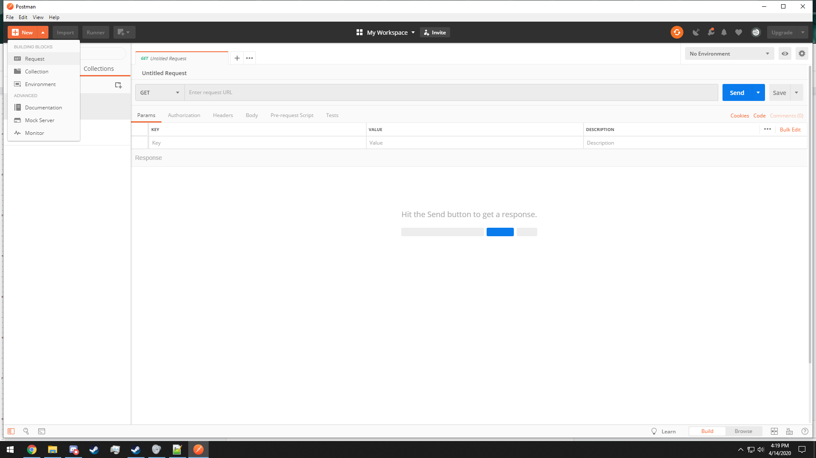
   4. Give it a good name and make sure the previously created collection is selected in the lower area.  
      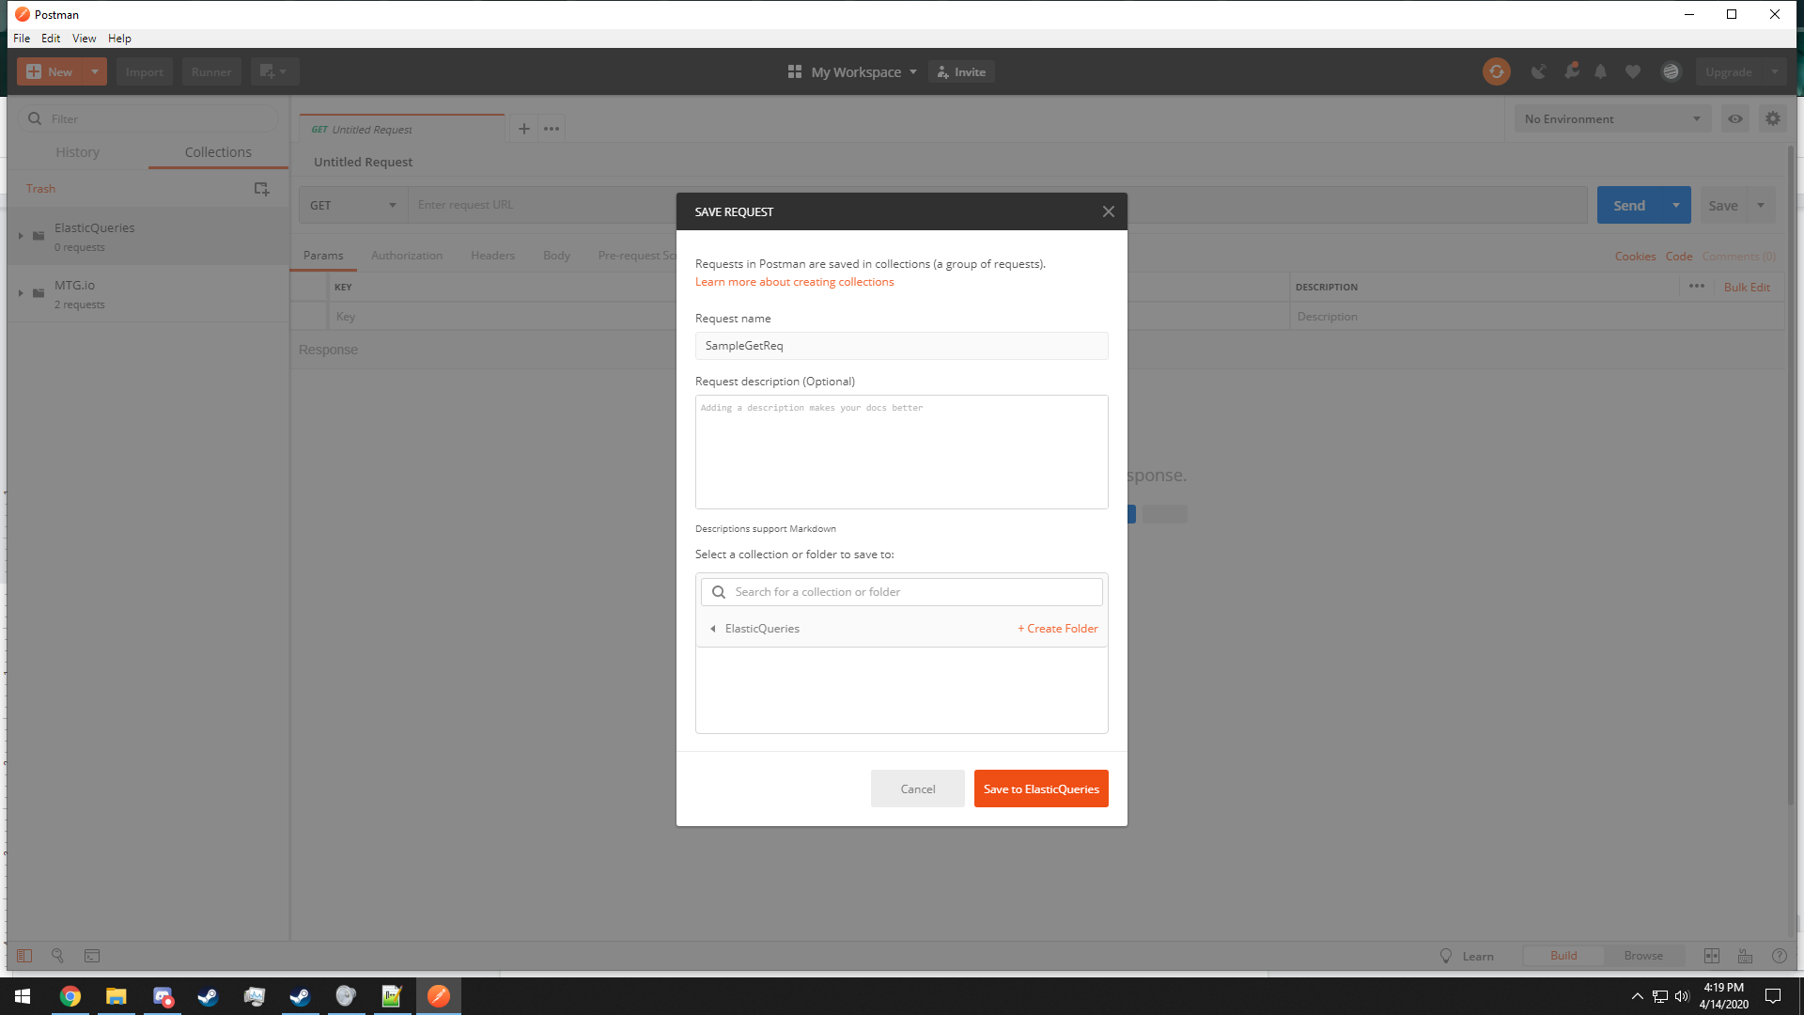
   5. Type in the External IP shown in GCP into the request bar followed by :9200 which indicates the port.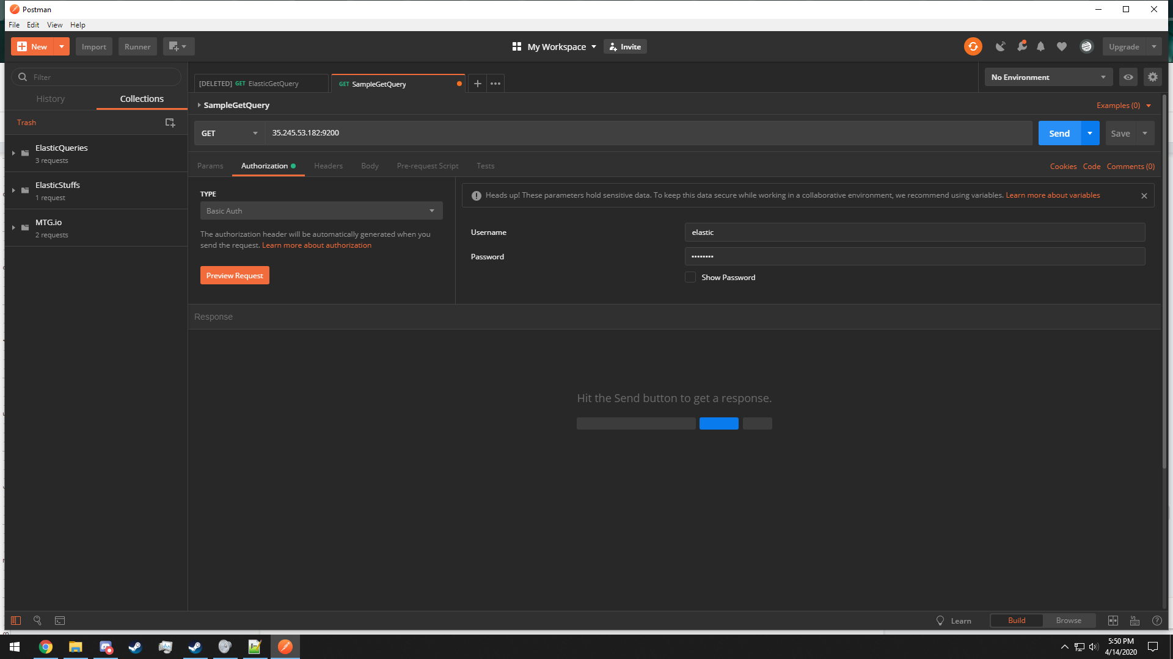
   6. Go to Authorization and select Basic Auth, filling in the Username and Password from GCP  
      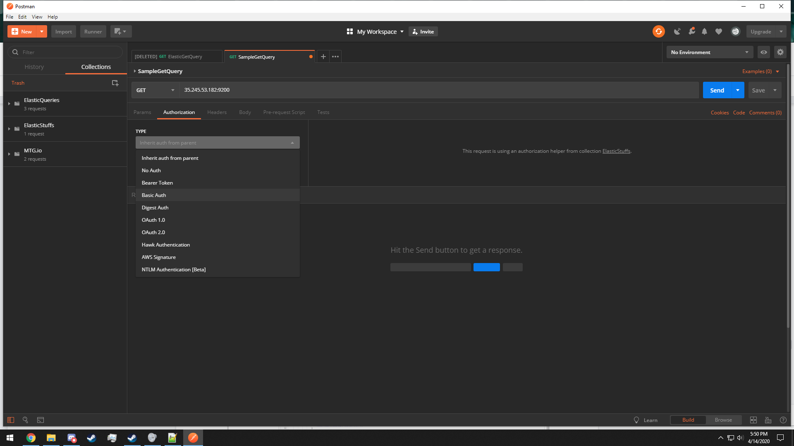
   7. Pressing send should give you information regarding your instance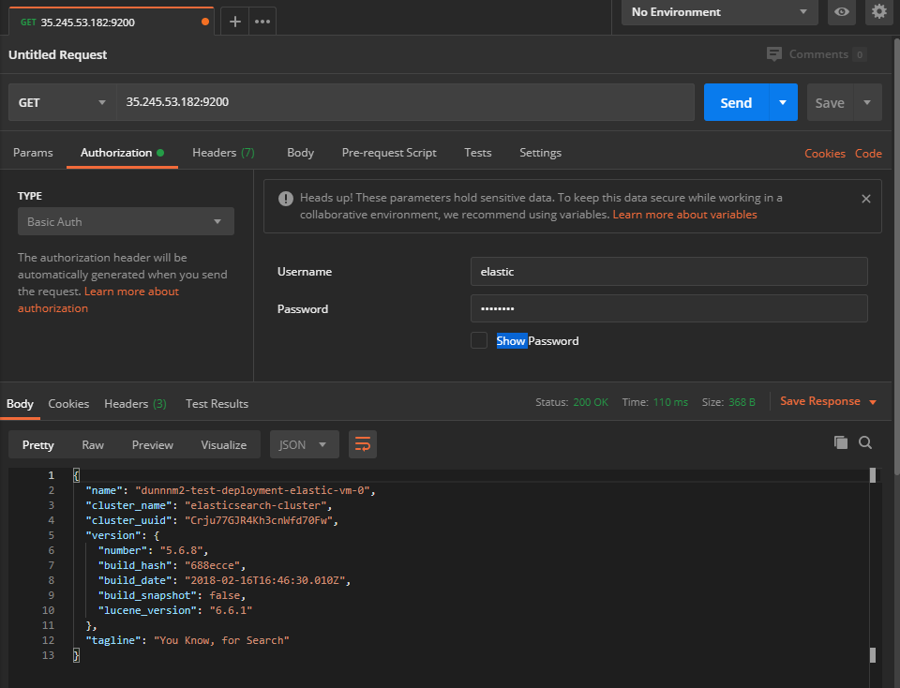
   8. Make a new Request as you did before but this time change the request type to PUT rather than GET and ensure that your authorization settings are correct  
      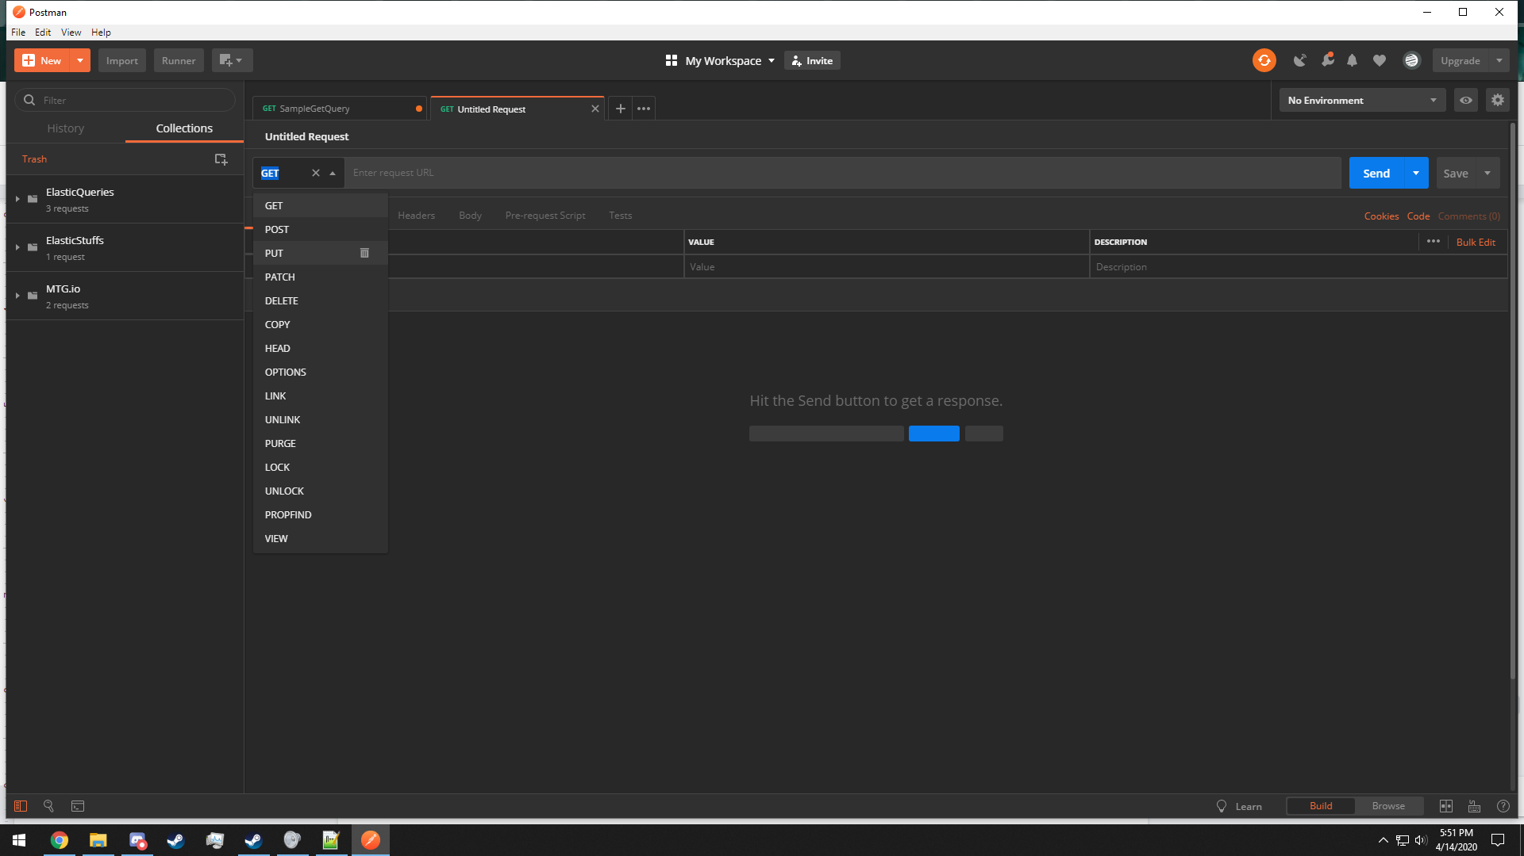
   9. Go to the Body tab and change the setting to raw and select JSON from the dropdown list  
      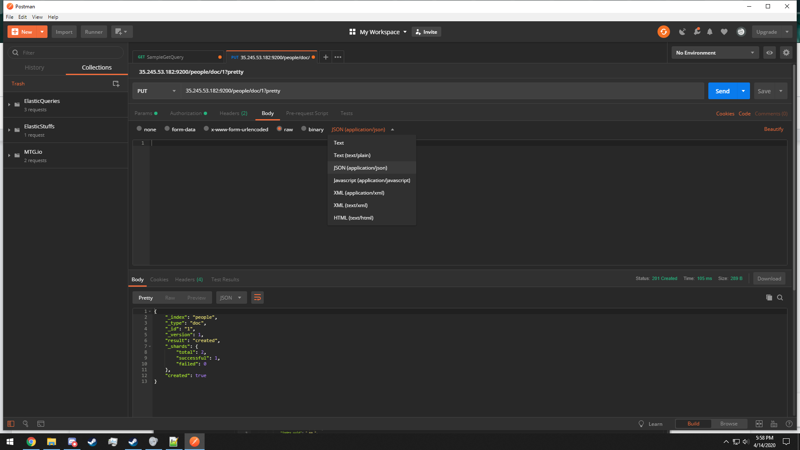
   10. Modify the request URL by adding a document name followed by /doc to declare which document to insert into and follow that with /1?pretty  
       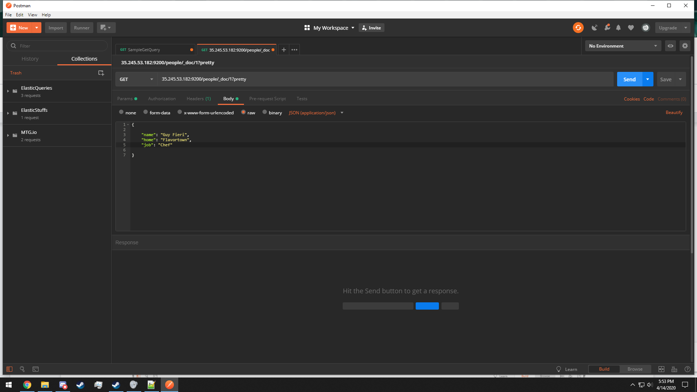
   11. Add data to insert into the document.   
         
       (This should be a PUT request rather than a GET request)
   12. Pressing send will produce the following and add the entry to the document  
       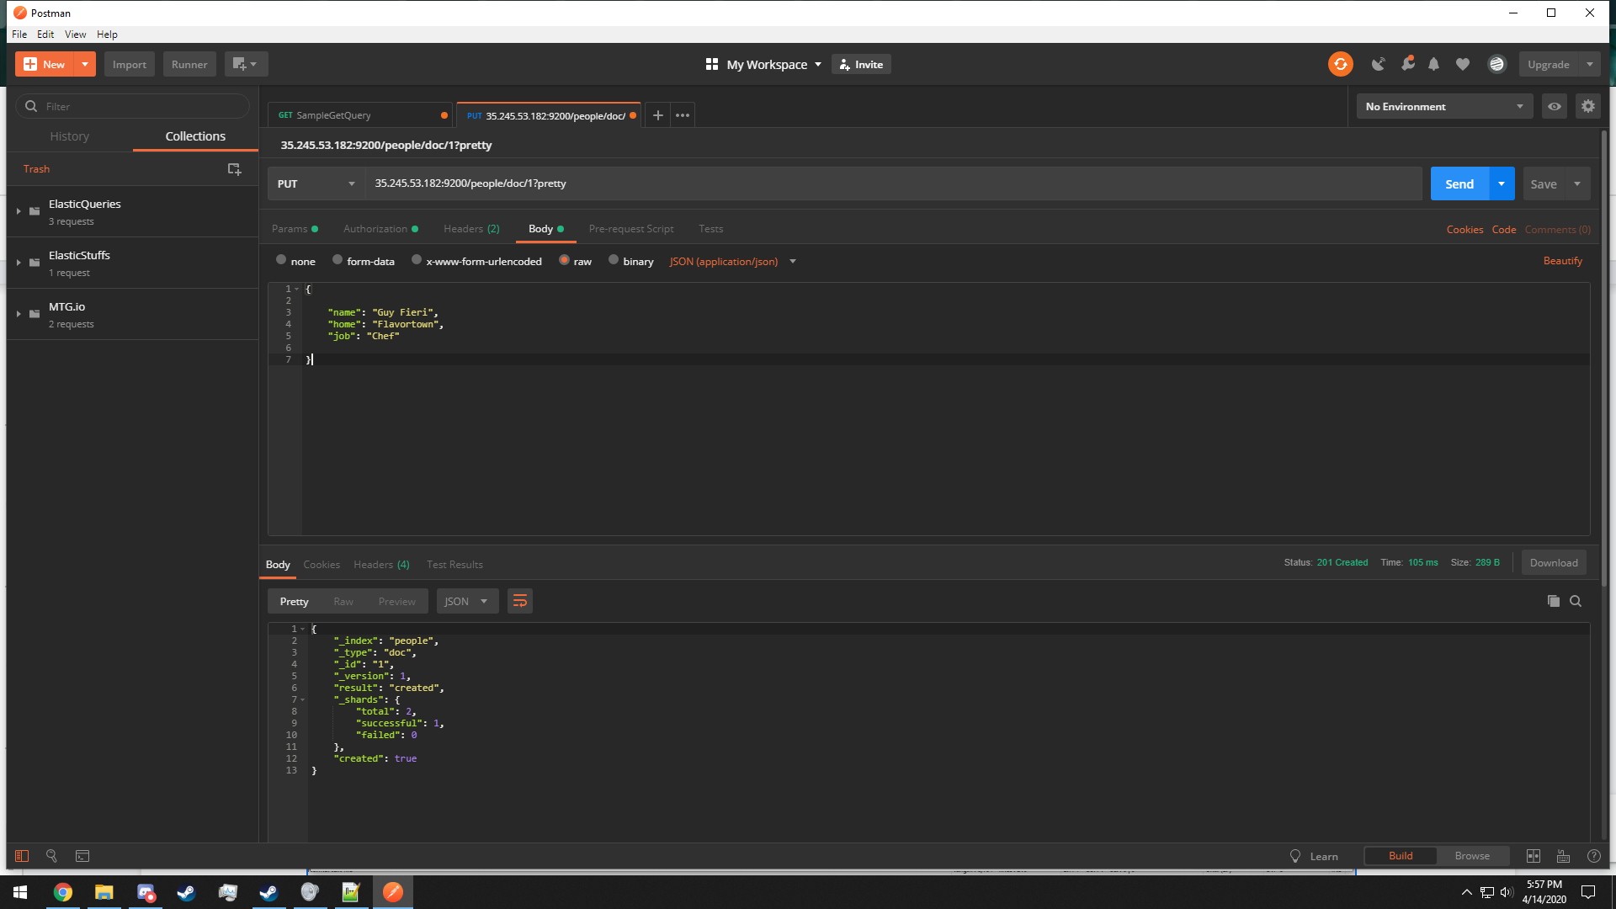
   13. Add a lot more data

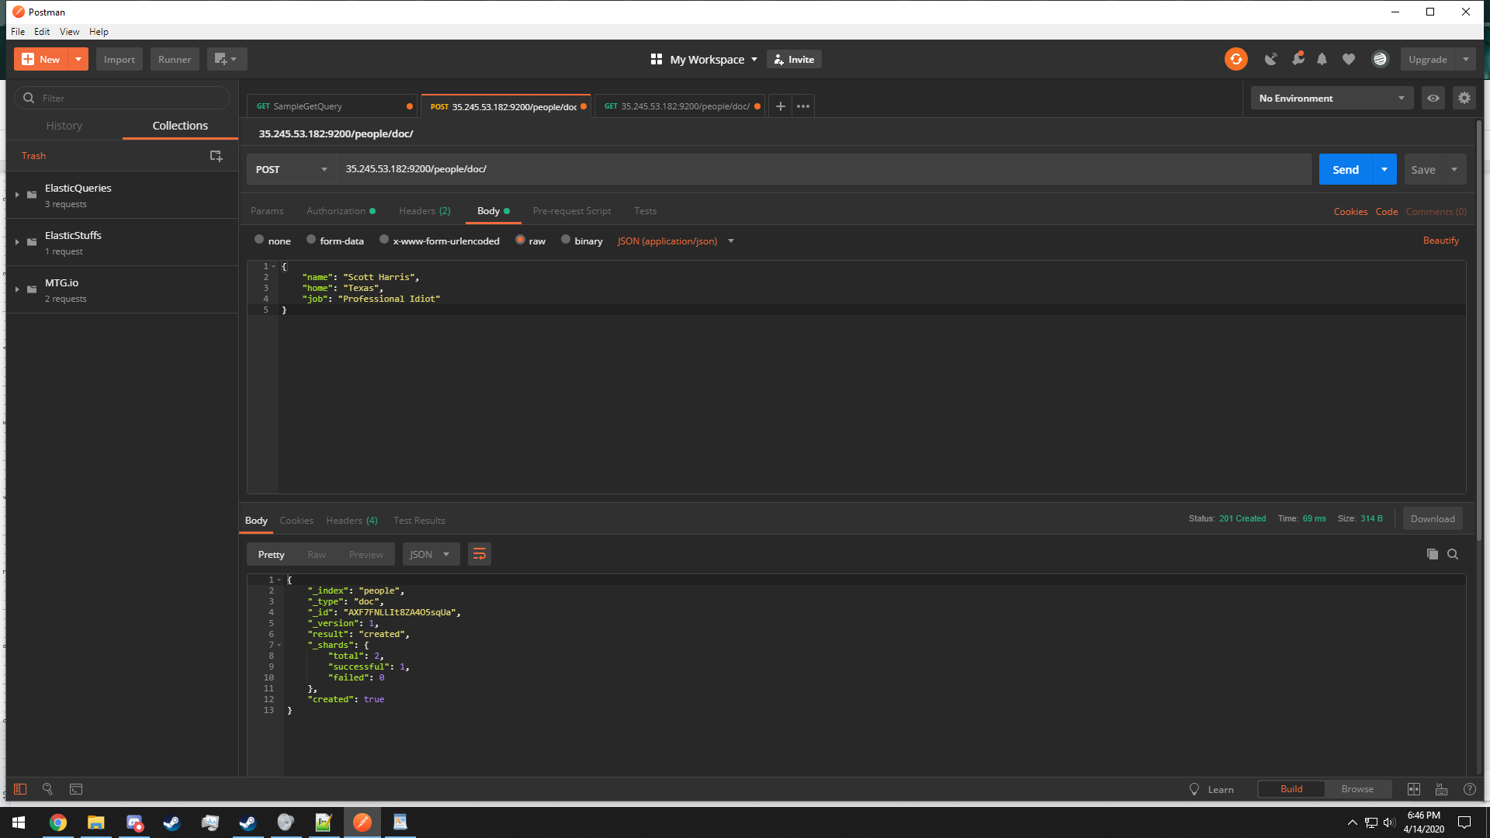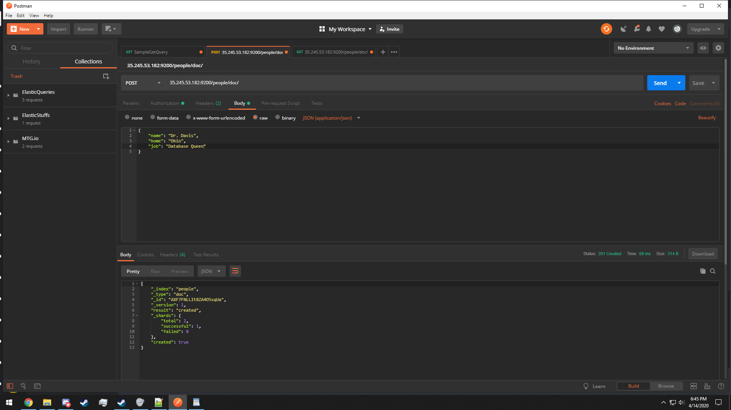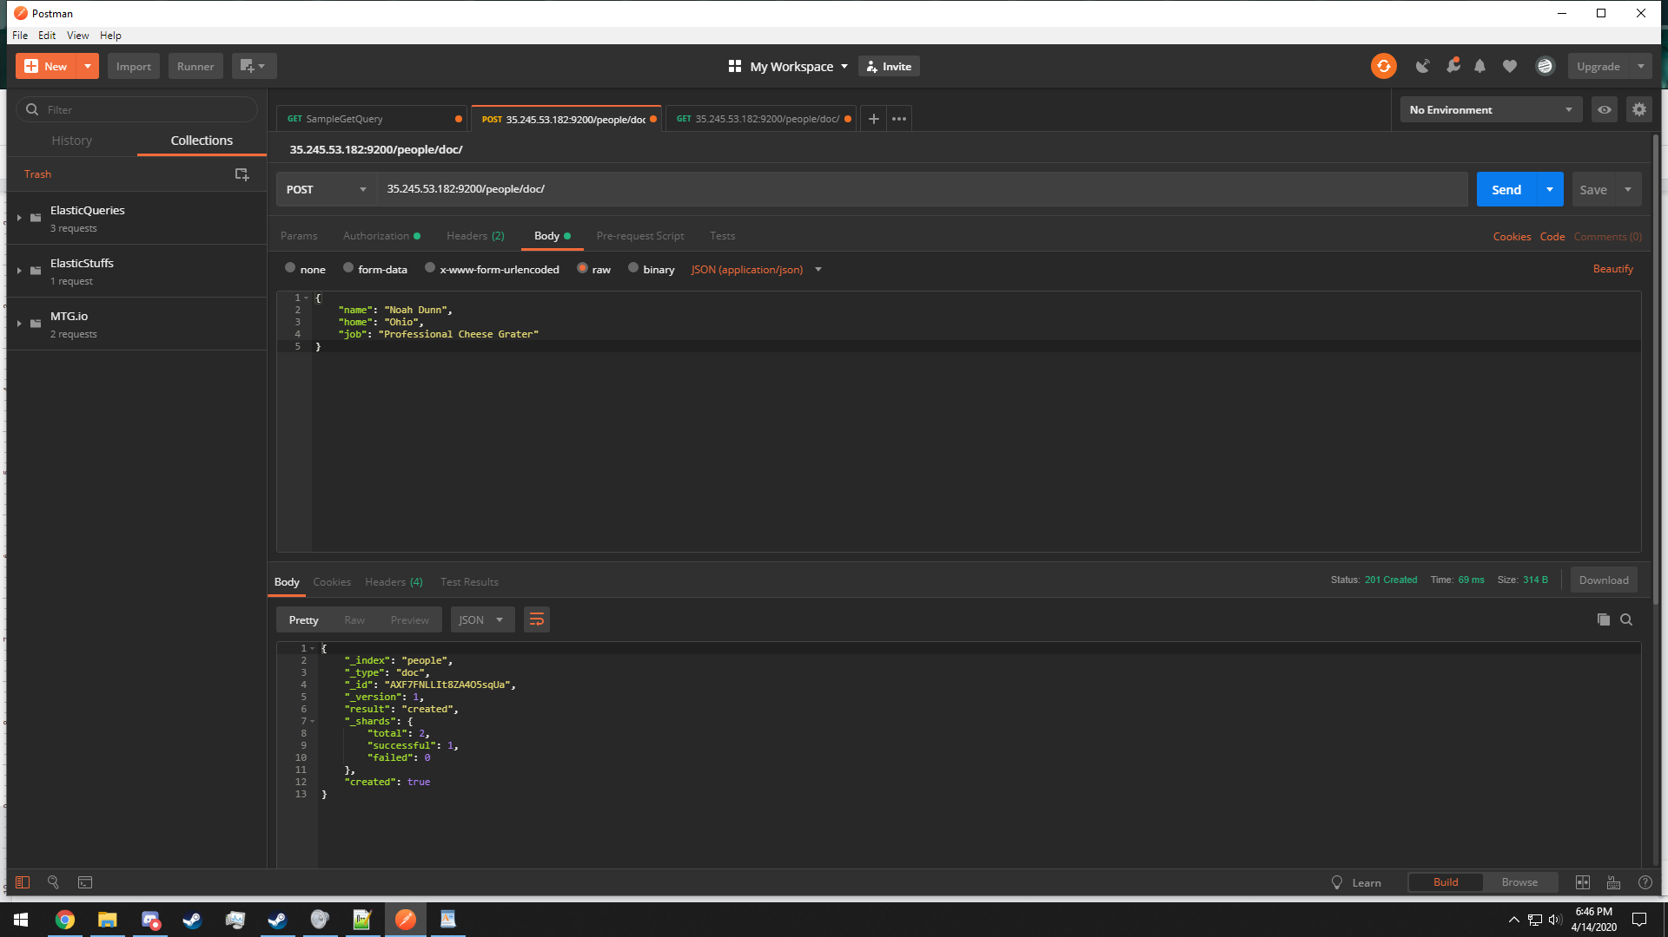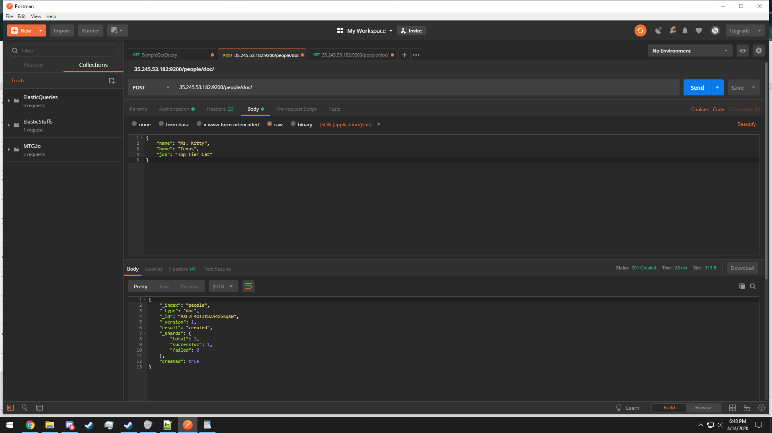  
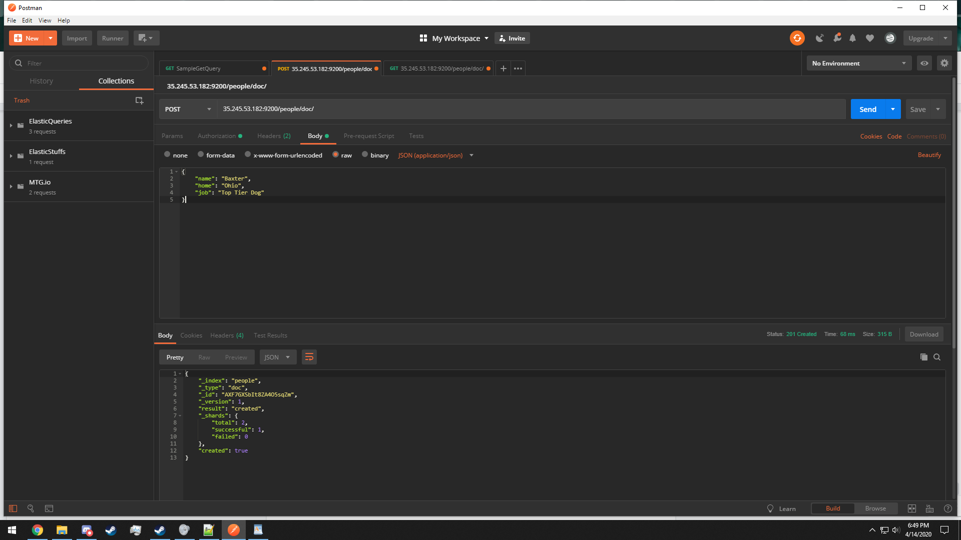

* 1. Creating a GET request to see what is in the people document should be as follows  
     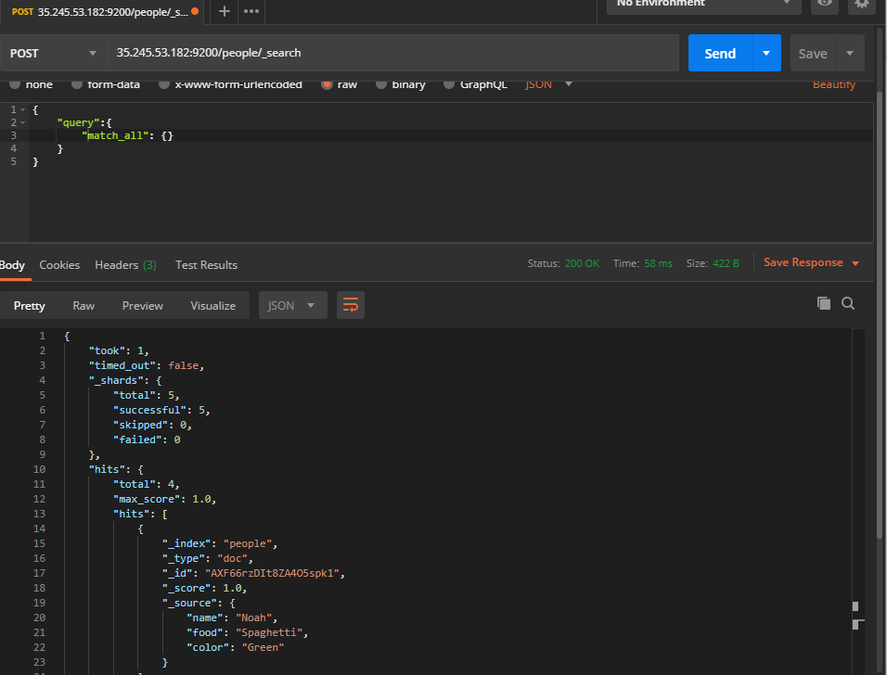

1. There are two methods of querying:
   1. URI construction
   2. DSL Language

URI construction usually makes use of GET calls, DSL usually uses POST requests

The following uses a URI query that searches for the name of ‘Guy Fieri’

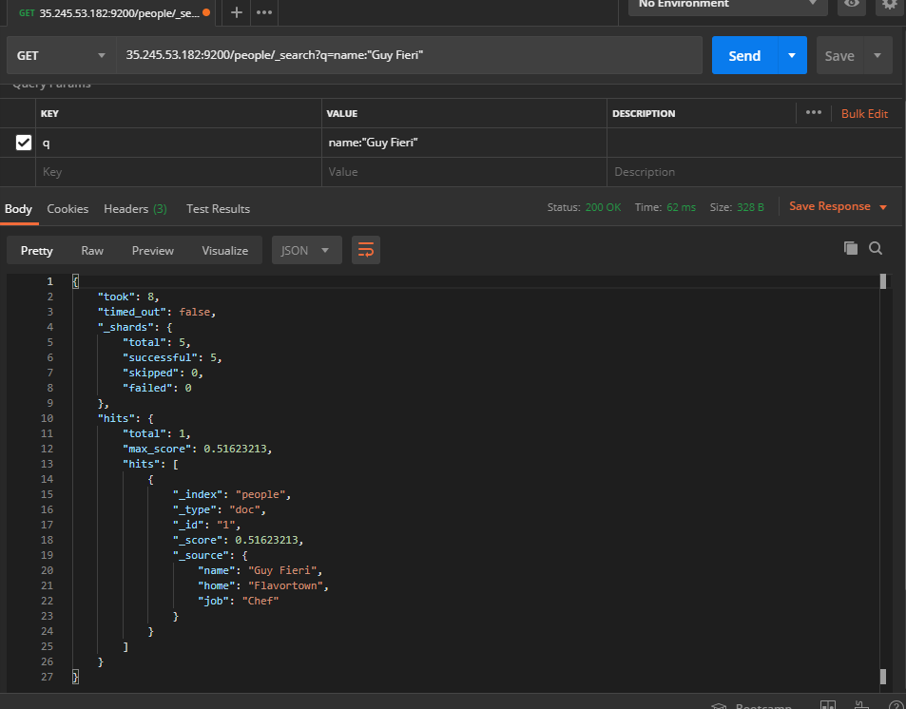

1. You can also use regular expressions to check certain fields against a matching regex.

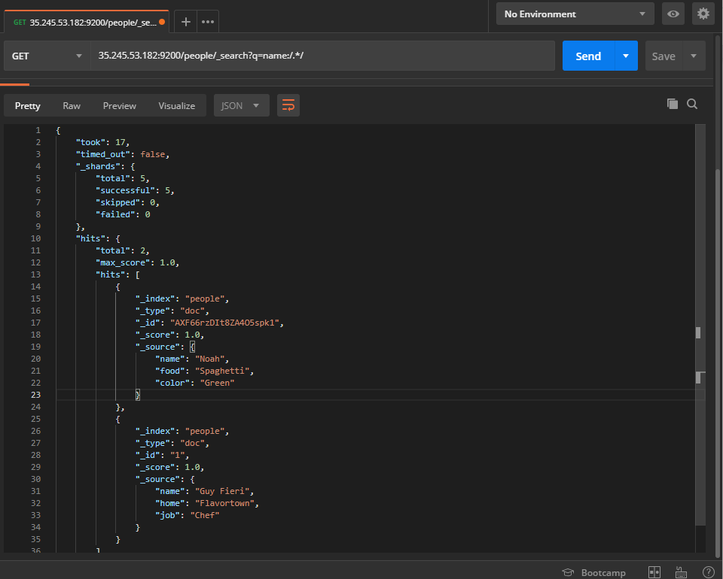

1. Here are the equivalent queries in DSL

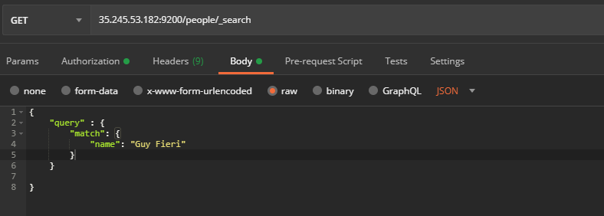

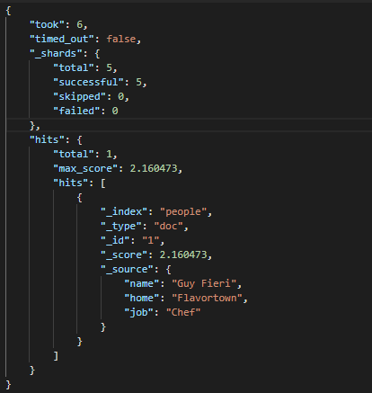

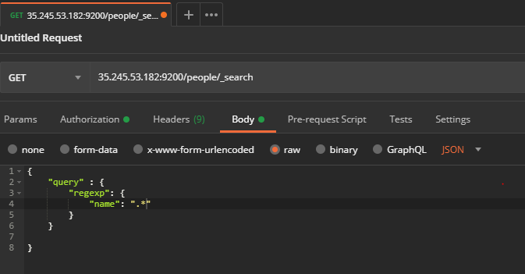

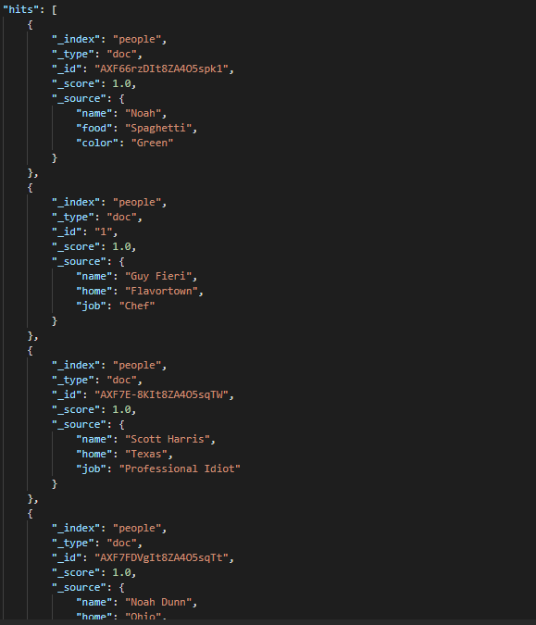

1. One of Elasticsearch’s primary query features is its use of relevance scoring for queries that are almost correct. Try running a normal query in the following format.

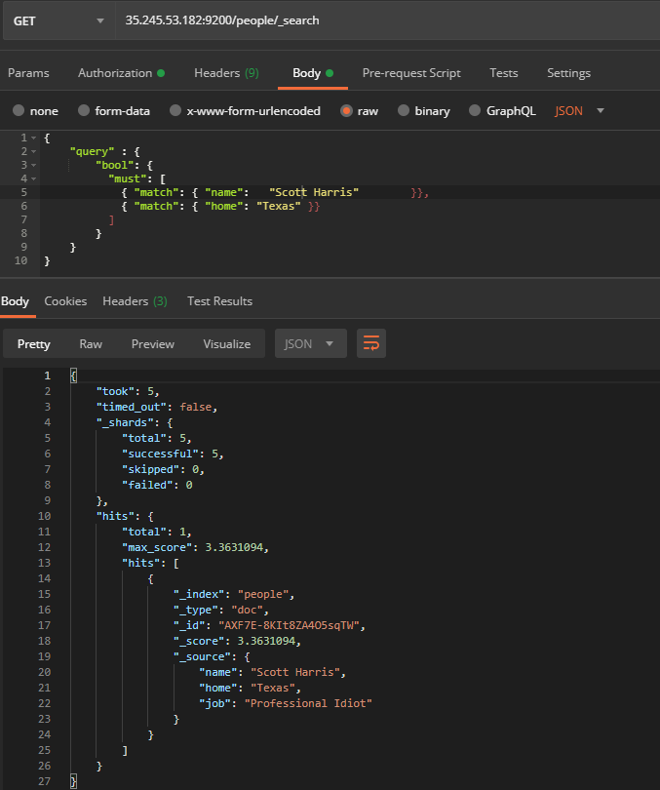

1. Now mess up some of the input on purpose. The relevance score (3.3631) will drop, but we will still be able to retrieve the same entry from the document.

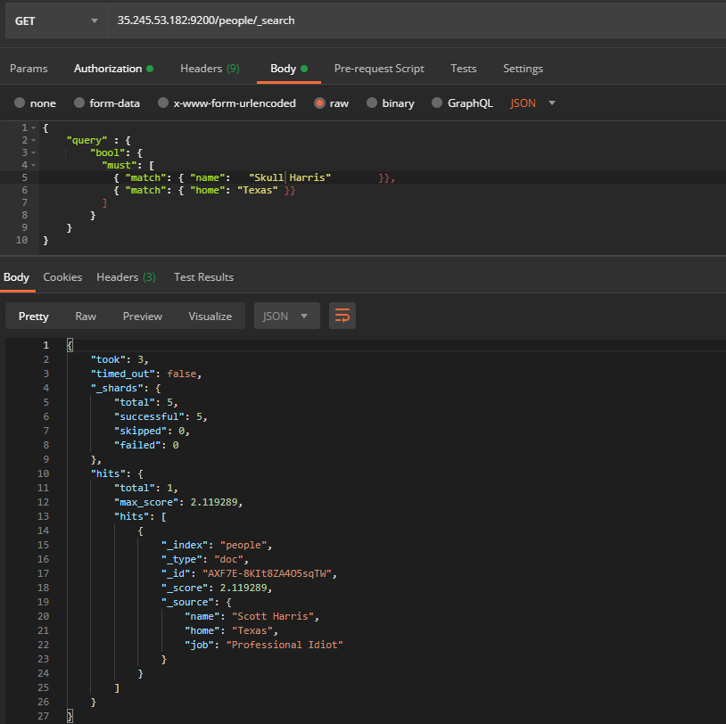

1. Note: In even more complex queries, the “fuzzy” key can be used to specify exactly how much difference between two words we want to allow. <https://www.elastic.co/guide/en/elasticsearch/reference/current/query-dsl-fuzzy-query.html>
2. Add some new entries to a new document called salaries

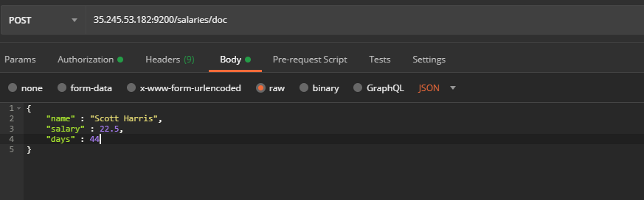

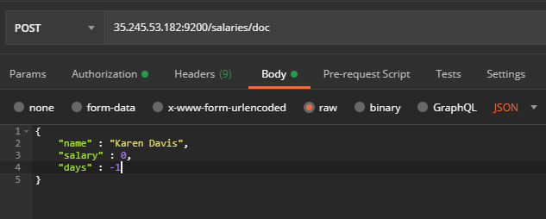

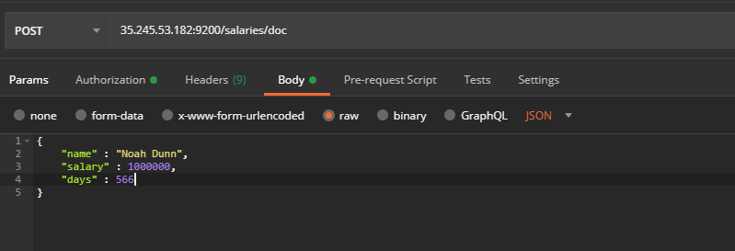

1. If you happen to double add an entry in this or any document, you can use the /_delete_by_query clause to remove all entries

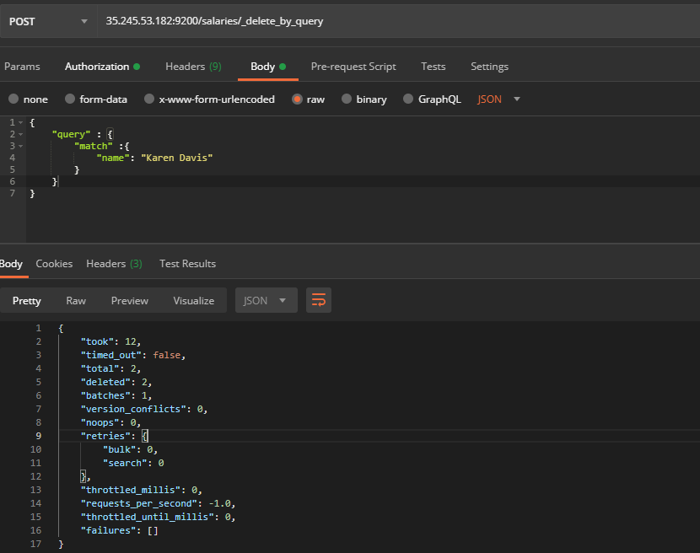

1. Use the OR operator to search for keywords in a specified field across documents

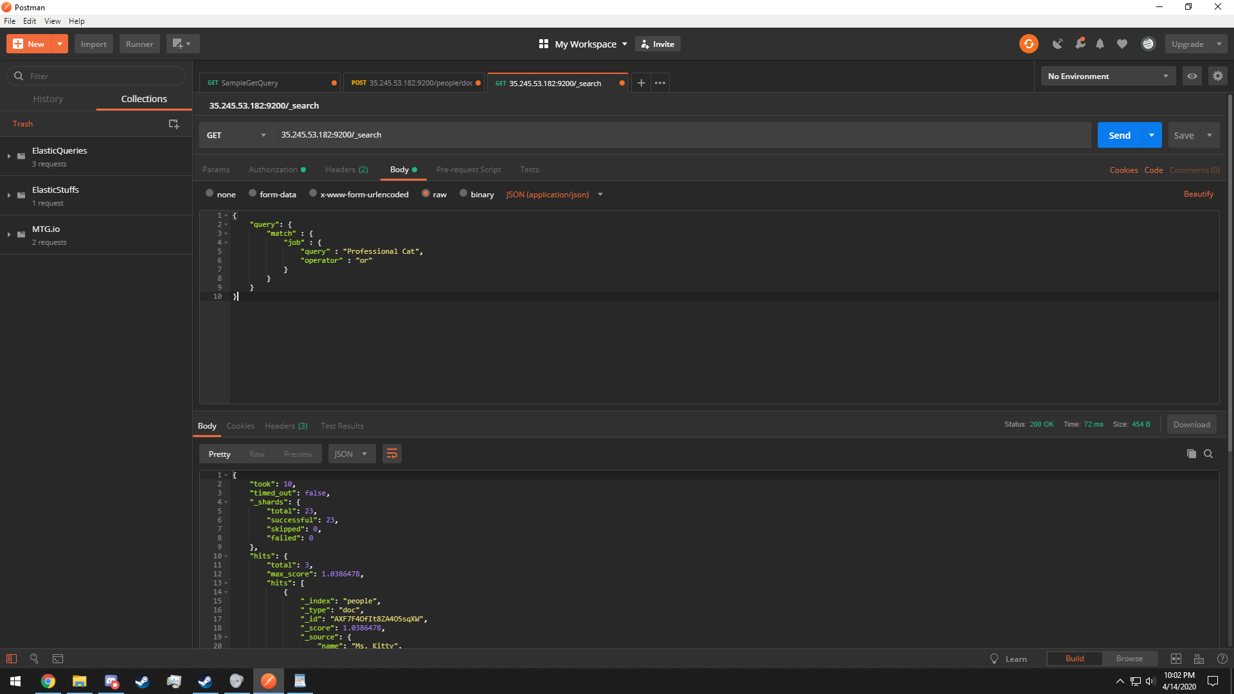

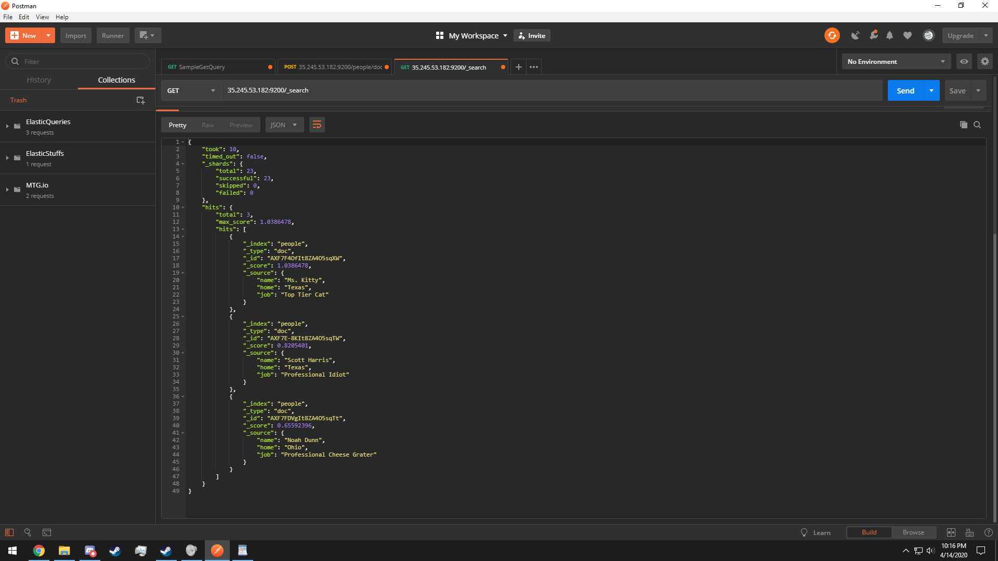

This concludes a comprehensive introduction to the installation, running, and querying of the Elasticsearch database system.